1. Create a webpage about one of your favorite musicians, similar to the example below:

5 points

Use the following HTML containers:

* <header> with <h1> heading that contain the musician's name
* <main> with two paragraphs:
  + 1st paragraph gives some background information
  + 2nd paragraph links to at least one website about the musician
* <footer> that names the webpage's creator

Although the HTML structure must conform to the instructions above, the text content does not need to match the example above.

**Web page (output):**

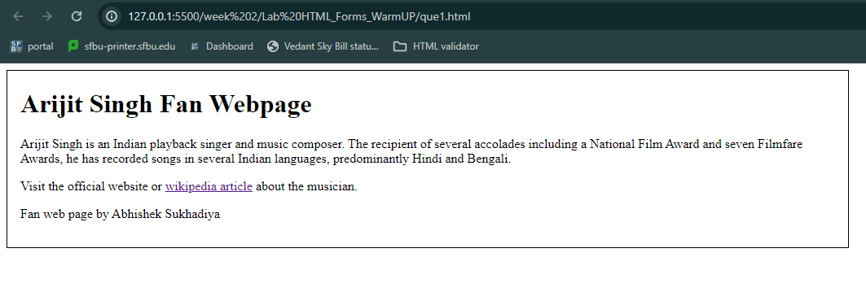

1. Create a web form as shown below that allows the user to enter personal information for joining a social network. The webpage uses CSS to align the form widgets vertically.

10 points

The form should:

* Use the POST method and the "multipart/form-data" enctype
* Submit to sfbu.edu

**Web page (output):**

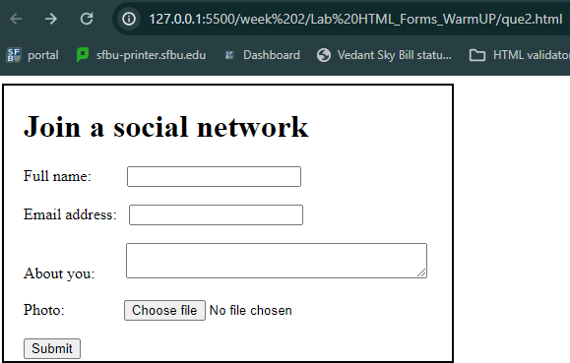

1. Create the form so the user can enter a birthday message and select various message options. The webpage uses CSS to align the form widgets vertically. The webpage should look like the following: 10 points

The form should:

* Use the proper expression for email address
* Use a proper <input> for specifying a date to send the message
* Use a proper <input> for selecting the message color
* Use a number <input> with a default value of 0, minimum of 0, and maximum of 10 for number of times the message blinks
* Use a range <input> with a default value of 20, minimum of 0, and maximum of 50 for the music volume
* Use a proper that reads "Send Birthday Message"
* Specify an id attribute for all form elements that matches the given for attribute of each associated <label>
* Specify a name attribute for all form elements that matches each element's id attribute

**Web page (output):**

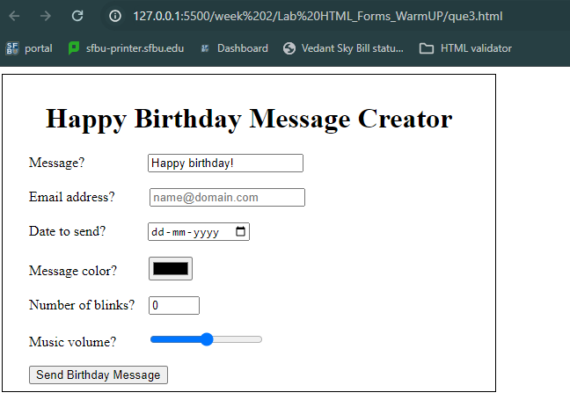

1. Add a form to index.html that allows the user to select a team's starting lineup for a game.

10 Points

The form should:

* Use the POST method
* Submit to sfbu.edu
* Use a <p> to surround related labels, form widgets, and fieldsets
* Use a <fieldset> and <legend> with radio buttons for choosing Draft or Final. The radio buttons' name attribute should be "status" with values "Draft" and "Final".
* Make the Final radio button checked by default
* Add a <label> to each radio button so clicking the label text selects the radio button
* Use a drop-down with the following dates: March 20, March 24, April 2, April 6, April 13. The <select> name attribute should be "gameDate", and each <option> should use a value identical to the option's date.
* Use a <fieldset> and <legend> with check boxes for choosing players: Aarav Agarwal, Ava Johnson, Julio Ortiz, Liam Rubio, Emma Witherspoon. The name attribute "player" should be used for all check boxes, and each check box should use a value identical to the player's name.
* Add a <label> to each checkbox so clicking the label text selects the checkbox
* Use a submit <input> with value "Submit"

**Web page (output):**

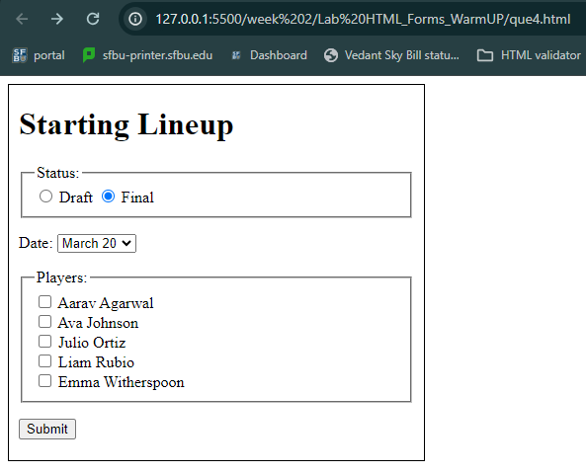

Instructions for submission :

1. Paste the screenshots of your output as you see on the web page
2. Submit the html files of every question.